ECOLOGIST
APPLICANT PACK
July 2026

HELLO
Thank you for your interest in Biodiverse Consulting. Launched in 2019, Biodiverse Consulting has grown rapidly to become one of the UK’s leading providers of biodiversity and ecology consultancy to the built environment and construction world. We work with a range of national clients (including major retailers, housebuilders, utilities providers and major charities) to enhance nature and biodiversity.

Our 25-person team is made up of experienced environmental experts and support staff who are committed to exemplary and sustainable placemaking that benefits communities, people and nature. Based in a stunning Grade 2 listed building, set in a beautiful country estate near Newcastle upon Tyne coming to work is a pleasure!

We are seeking a motivated, talented, professional Ecologist to join our consultancy team, offering creative solutions that benefit both business and nature. This is an amazing opportunity to shape and deliver traditional and non-traditional biodiversity services within a growing environmental consultancy.

Joining our talented team you will share our commitment to our core values of integrity, adaptiveness, collaboration, creativity, and passion in all that we do.

We are committed to ensuring our employees are fully supported and nurtured professionally and personally. Our friendly and supportive working environment is a great space to further develop your skills, build your career and work with great people with a shared purpose.

This pack describes the position in more detail and the key attributes required, alongside an overview of what you can expect from us. Your application should take the form of a CV and cover letter detailing why your experience, knowledge and skills make you ideal for the role. Your application should take the form of a CV and cover letter detailing why your experience, knowledge and skills make you ideal for the role.
Send to talent@biodiverseconsulting.co.uk

I look forward to hearing from you and if you’d like an informal chat then please get in touch.

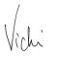

Vicki Mordue | Managing Director
+44(0)191 303 7805 | talent@biodiverseconsulting.co.uk

JOB DESCRIPTION
POSiTION | ecologist
LOCATION | HYBRID: Office based + Home working
SALARY | £26,520 - £33,660 pro rata (dependent on experience)
HOURS | full time (37.5 hours per week)
TERM | Permanent
benefits | Health Insurance  hybrid working  flexible working patterns  professional membership  EXTENSIVE TRAINING AND DEVELOPMENT SUPPORT  ANNUAL PROFIT SHARE BONUS

Role summary
To bid, win and deliver a range of ecological survey, assessment and net gain projects that exceed client expectations while contributing to natures restoration. As part of our ecology team, you will be responsible for the management and safe delivery of a range of interesting projects on time and on budget, working with clients, collaborators and subcontractors, as required.
You will have input into the design and delivery of solution focused services that meet clients’ needs and regulatory requirements and there will be a requirement for proactive marketing of the consultancy.
You will work with clients, colleagues and collaborators in a professional, competent and friendly manner and deliver work within and adhering to Biodiverse Consulting’s framework of policies and procedures.
Role responsibilities
1 | Produce bespoke fee proposals for a range of services and project types
2 | Undertake desktop study, preliminary ecological assessments, protected species and habitat surveys, shadow Habitat Regulation Assessments (HRA) and Ecological Impact Assessment (EcIA) including analysis, interpretation and application to projects
3 | Method Statement production and Ecological Clerk of Works
4 | Delivery of Biodiversity Net Gain Assessments (including UKHabs field survey and metric)
5 | Report production (ecological/habitat) and technical review (including map production)
6 | Protected Species Licence Applications and implementation (including appropriate mitigation and compensation schemes)
7 | Efficient, professional client relationship management
8 | Project management (including budgetary and resource planning) of projects
9 | Ecology service design, input and continuous improvement
10 | Train, mentor, and support colleagues through a clear and structured programme
11 | Line management of a team
12 | Promotion of services and company via digital media, including website and social media
13 | Adherence to company Health and Safety policies, practices, processes and procedures

person specification
You will have ecology consultancy experience and knowledge of current and incoming legislation, species and habitats. It is the proactive attitude, client focus and creative approach however, that will successfully deliver this role.
The person specification details the key attributes that are essential for the post and there will be a requirement to evidence these at interview.
experience & Knowledge
Minimum two years working in ecology consultancy
Report writing
GIS use for map production
Ecological surveys and Bat Roost Appraisal experience
Protected Species Surveys
Application of Biodiversity Net Gain Assessment including use of Biodiversity metric
Client/customer success
Project management skills (including financial management and resource planning)
Understanding of Ecological Impact Assessment
Understanding of Habitat Regulations Assessments
Knowledge of Development Planning Regime
Knowledge and application of wildlife and habitats legislation including UK and EU legislation, planning policy and best practice
Tree climbing experience (desirable)
Qualifications & Memberships
Minimum of BSc degree in Ecology or closely related subject
Minimum of 1 Protected Species Licence at Class 2 level or progressing towards (desirable)
CIEEM membership (minimum Qualifying)
Personal Qualities
Strong time management and levels of personal organisation
Motivated and able to use own initiative
Able to meet tight deadlines and prioritise own work to meet/manage client expectations
Excellent oral and written communications skills, including attention to detail in all aspects of the role
Ability to maintain client and commercial confidentiality
Prepared to work unsociable hours, occasional weekends, able to drive and access to own vehicle

Your offer
- A rare opportunity to shape and influence a growing consultancy both in terms of the services we offer and the team we build
- A dedicated training and development budget to support your growth
- Health insurance covering virtual GP appointments, employer wellbeing, physiotherapy
- Professional environmental membership
- Flexible working hours and annualised Time off in Lieu
- Grade II listed offices near Newcastle-upon-Tyne surrounded by wildlife
- Winter working hours to reflect the changing seasons and the effect on our work
- Performance-related bonus scheme
- 22 days holiday plus bank holidays + an additional day off on your birthday
- Pension scheme

our values
Delivering quality services with a positive environmental impact is at the heart of everything we do. We are creative problem solvers, client focused and with a genuine belief that development can deliver environmental gains that balance business and biodiversity.
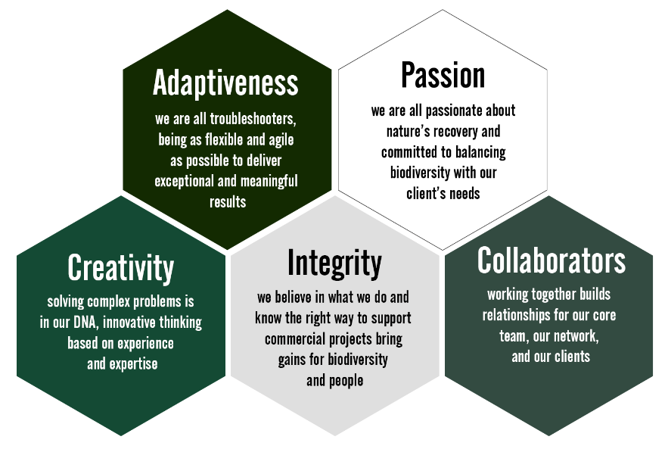
We truly believe in supporting sustainable placemaking that benefits communities, people and nature. And that’s why we partner with businesses, the public sector and charities to create positive change that makes a tangible difference to our world.

Dissington Hall
Dalton
Newcastle upon Tyne
NE18 0AD
www.biodiverseconsulting.co.uk

